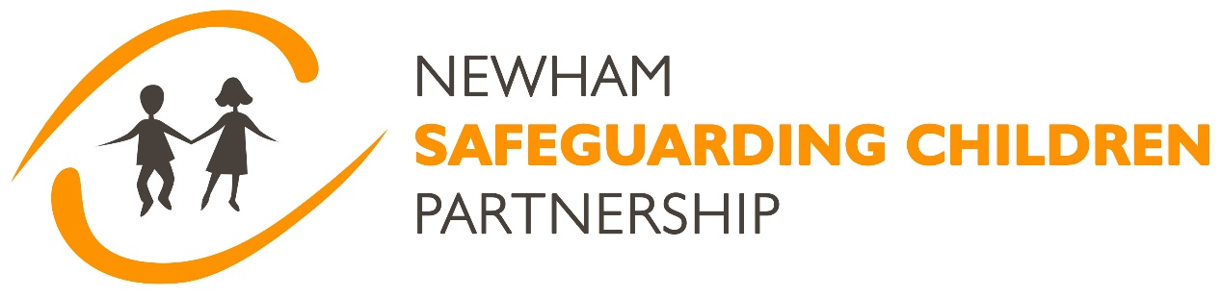

Newham Safeguarding Children Partnership (NSCP). The published arrangements. 19.11.24

- Introduction

This agreement sets out the decisions made by the defined statutory partners in Newham which are Newham Council, the Integrated Care Board and the Metropolitan Police, to implement the requirements of the Children and Social Work Act 2017 and Working Together to Safeguard Children 2023 in respect of how local safeguarding arrangements are organised. The Department for Education (DfE) statutory guidance sets out what organisations and agencies who have functions relating to children must and should do to help, protect and promote the welfare of all children and young people under the age of 18 in England.

Recognising the importance of a holistic approach to safeguarding, Newham has taken an additional step by including education partners as a crucial component of the partnership. This is reflected in the active participation of the Director of Education and Head Teacher representatives from both secondary and primary schools, ensuring that the educational sector is fully integrated into the safeguarding framework. This expanded partnership strengthens the collective efforts to protect children and ensures a comprehensive safeguarding strategy within the local area. This agreement will therefore also apply to the education partners.

Vision
Our vision is to make Newham the best place for a child and young person to grow up, be safe and provide the environment and support for them to reach their full potential.

Objectives
To coordinate what is undertaken by each agency to safeguard and promote the welfare of children; and ensure that all agencies are working together effectively.

Partnership Principles.
The partnership promotes a culture of high support, high challenge and operates using a relational model with an inherent focus on collaboration thereby improving outcomes for children, young people and families. Achieving equity, diversity and inclusion is a key principle with partners committed to tackling racism and discrimination that our children, young people and families experience. Learning together is critical to driving further enhancement in the partnership and improving outcomes for our families.

Voices of children and families.
Hearing the voices of children and their families is an integral part of the work of the partnership. Their views are already routinely included in case audits and in other Performance and Quality Assurance activity. Within the Child Safeguarding Practice Review process their experience is also specifically explored. Scrutiny activity will also be more inclusive of children and families using existing mechanisms such as through the work of the youth empowerment programme. It will be important to ensure that children and young people who are involved in the work of scrutinising the Partnership can be properly supported.

Understanding the lived experiences of our children and young people in Newham in terms of culture, poverty, identity, diversity and the environment in which they are living is crucial if we are to address safeguarding issues. The importance of challenging racism, adultification and intersectionality are just some areas where the partnership needs to take a lead. Successful outcomes for children depend on strong relationships between parents/carers, children and young people and the practitioners working with them. The relational model is the means through which practitioners work collaboratively with individuals and families to establish a shared understanding of what needs to be done, and by whom, in order for the concerns about a child's wellbeing to be resolved. A child centered approach is fundamental to safeguarding and promoting the welfare of every child.

Strong multi agency and multidisciplinary working is vital to identifying and responding to the needs and risk that may be present for children and families. The details of how this is going to be delivered in Newham can be found within this document.

The purpose of multi-agency safeguarding arrangements is to ensure that, at a local level, organisations and agencies are clear about how they will work together to safeguard children and promote their welfare. This means:

- There is a clear shared vision for how to improve outcomes for children locally across all levels of need and all types of harm.
- When a child is identified as suffering or likely to suffer significant harm there is a prompt, appropriate and effective response to ensure the protection and support of the child. organisations and agencies are challenged appropriately, effectively holding one another two account.
- The voice of children and families combined with the knowledge of experienced practitioners and insights from data, provides a greater understanding of the areas of strength and or improvement within arrangements and practice.
- Information is analysed shared and broken down by protected characteristics to facilitate more accurate and timely decision-making for children and families and understand outcomes for different communities of children.
- Effective collection, sharing and analysis of data, enables early identification of new safeguarding risks, issues, emerging threats, and joined up responses across relevant agencies.
- Senior leaders promote and embed a learning culture which supports local services to become more reflective and implement changes to practice.
- Senior leaders have a good knowledge and understanding about the quality of local practice and its impact on children and families.

Geography. Newham will be the geographical area for these arrangements. Each of the statutory partners has a defined senior manager responsible for their services in Newham, so accountability is clear. There is some cross borough working particularly with Waltham Forest as we share the police Basic Command Unit; and also with the ICB which operates across Newham, Waltham Forest, Tower Hamlets, Hackney and the City of London.

- Strategic leadership and accountability.

The Lead Safeguarding Partners (LSP) as defined in legislation are the Chief Executive of the Local Authority, the Chief Executive of the ICB, and the Chief Officer of the relevant police force. They are accountable for the effectiveness and outcomes of multi-agency safeguarding arrangements in their area. Within Newham Council the Chief Executive will fulfil this role. Within the ICB, as they cover 8 local authorities, the role will be fulfilled by the Chief Nursing Officer on a day to day basis. An annual meeting was initiated by the ICB and is scheduled for December 2024 by the NEL Chief Executive Officer and the NEL Chief Nursing Officer with the seven chief executives from local authorities and the City of London across the NEL footprint, together with a nominated lead by the Assistant Commissioner of the Metropolitan Police. There are also scheduled bi-annual meetings between the NEL CEO and CNO with the SAB chairs and independent scrutineers across the NEL footprint.

As the Metropolitan police cover 32 local safeguarding partnerships the strategic leadership will be held at Assistant Commissioner level however on a day to day basis the role will be fulfilled by the BCU commander. It is anticipated that across London there will be an annual meeting of all the Chief Executives of the local authorities; the Chief Executives of the ICBs; and the police Assistant Commissioner. Within Newham, Education has been identified as the “fourth statutory” partner since 2019 and therefore the Director of Education will also be identified as a LSP. LSPs must be able to: speak with authority for the safeguarding partner they represent; take decisions on behalf of their organisation or agency and commit them on policy, resourcing and practice matters; hold their own organisation or agency to account on how effectively they participate and implement the local arrangements. The LSPs in Newham will meet annually and their terms of reference are attached at Appendix 1.

Each LSP should appoint a Delegated Safeguarding Partner (DSP) for its agency. DSPs must be sufficiently senior to speak with authority; able to take decisions on behalf of the LSP and able to hold their own sectors to account. In Newham DSPs will include: Director of Children Services (DCS), the BCU commander, the Deputy Director of Safeguarding ICB, the Director of Nursing ICB and the Director of Education. They will comprise the NSCP Executive along with the Public Protection lead from BCU, Director of Early Help and Safeguarding CYPS, the chairs of the NSCP sub groups, and the chair of Education Partnership Board (EPB) steering group. The LSPs should appoint one of the DSPs as the partnership chair of the NSCP Executive. In Newham this role will be rotated on an annual basis. The purpose of this role is to provide greater continuity across local areas and act as the conduit between the DSPs and the LSPs providing feedback and escalating collective risk and issues to the LSPs as necessary. One of the functions of the NSCP Executive is to provide oversight of the NSCP business plan which is published on the website. There have been opportunities over the last few years to identify joint priority areas with the Newham Safeguarding Adults Board for example work on all age exploitation which it is hoped will continue. The current business plan will be revised and updated in March 2025 to reflect this partnership agreement. The DSPs will meet quarterly as the NSCP Executive and their terms of reference are attached at appendix 2.

Relevant agencies. The ‘relevant agencies’ are those organisations and agencies whose involvement the safeguarding partners consider are required to safeguard and promote the welfare of children in Newham. They are listed in appendix 3. As relevant agencies they should: have a clear understanding of their responsibilities in relation to safeguarding children in Newham, and how they will discharge them; cooperate with safeguarding partners to improve, implement, and monitor effectiveness of the local safeguarding arrangements; share information and data about safeguarding issues and concerns affecting the children involved in their organisation to contribute to local priorities; ensure local multi-agency safeguarding arrangements are fully understood, and rigorously applied within their organisation. The LSPs will assure themselves that relevant agencies have appropriate and robust safeguarding policies and procedures in place and that information is being shared amongst all relevant agencies and the safeguarding partners. Operationally, this will be led by the Performance and Quality Assurance subgroup through an annual audit. Relevant agencies including VCSE, Probation, Fire and Rescue, a sporting representative, a range of education representatives including early years etc, the LBN Councillor with lead responsibility for CYPS, Community safety lead, Adult safeguarding, Youth Offending, Housing, CAFCASS, BARTs NHS Trust, 0-19 Health services, East London Foundation Mental Health Trust, have all been meeting on a bi monthly basis with the NSCP Executive for the last year. This group will be now become the NSCP Partnership Group and membership will be extended to include other relevant agencies. This group will meet with the NSCP Exec on a quarterly basis. They will also be included in regular communications and invited to a range of learning and development events and partnership activities. The Terms of Reference are attached at Appendix 4.

- Working with schools, colleges early years, and other education providers. Schools, which includes infant, primary and junior schools, council-run secondary schools, academies, free schools, voluntary-aided schools and voluntary-controlled schools; colleges; early years and childcare settings and other educational providers; including alternative provision, all have a pivotal role to play in safeguarding children and promoting their welfare. People working in education settings play an important role in building relationships, providing direct support to children and identifying concerns and responding to those concerns. They may be the first trusted adult to whom children report safeguarding concerns. They are listed as relevant agencies in appendix 3. To promote engagement, involvement and to provide a strategic perspective the LSPs have agreed that the Director of Education, Newham Council as a LSP. For the last 4 years there has been a primary head and secondary head representative on the NSCP Executive and the Director of Education has also been a member of the group. The NSCP Executive have agreed to include the chair of the Education Partnership Board (EPB) steering group, which focuses on vulnerable children and safeguarding in their meetings. The chair of the steering group will provide a bridge between the NSCP Executive group and the EPB steering group. They will also identify members of this group to attend the NSCP quarterly partnership group as the agenda determines.

- Working with voluntary, charity, social enterprise (VCSE) organisations and sports clubs. Many voluntary, charity, social enterprise (VCSE) and sports clubs provide education and activities for children and young people as part of their work. The staff and volunteers working with children in these settings will often play an important role in building relationships, providing direct support to children and identifying and responding to concerns. They can often be the first trusted adult to whom a child reports abuse therefore many these organisations will have a crucial role to play in safeguarding promoting the welfare of children. Over the last 12 months we have engaged with a number of VCSEs through the extended executive and this will continue as they will be involved in the wider NSCP Partnership Group. They will also be included in regular communications and invited to learning and development events.

- There are no youth custody facilities in Newham, however there is a London wide alternative to custody provision which is contract managed by Camden which will be named as a relevant agency.

- Residential children’s homes are named as relevant agencies. Residential homes for children are managed for safeguarding purposes by the contract manager in Newham Children and Young Peoples Services. We are working in collaboration with residential care providers as Residential children’s homes have a role to play in identifying concerns, sharing information and taking prompt action. Training will be provided to the managers and providers of homes about how these arrangements will work within the framework of the Children’s Homes Regulations.

- Information requests. Sharing of information between organisations and agencies within a multi-agency system is essential to safeguarding children and improving outcomes for children and their families. Safeguarding partners may require any person, organisation, or agency to provide them, any relevant agency for the area, a reviewer or another person, organisation or agency, with specified information. An information sharing agreement is in place.

- Independent scrutiny. Safeguarding partners must ensure that there are arrangements for effective independent scrutiny in place for their local area. An independent scrutineer will be appointed before the end of December 2024. The job description is attached at Appendix 5. It is anticipated that children and young people and their families will be engaged in scrutiny and existing mechanisms will be used for this. The LSPs will agree the areas of scrutiny on an annual basis and this will be reported back on through the annual report.

- Funding. Core funding is set out in the table below.

Expected Income 2024/25

Income source | Amount
Barts Health | £5,000
ELFT | £10,000
ICB | £50,000
Police | £5,000
LBN - CSC | £115,000
LBN - Education | £10,000
Housing | £5,500
Probation | £2,100
Total | £202,900

The details of the budget and expenditure will be included in the annual report of the NSCP. The NSCP is supported by a business unit which comprises of a full time service manager; a 0.25 learning and workforce development lead; a 0.4 Partnership Coordinator to provide strengthened business support and a 0.6 Partnership Development Lead (12-month contract) to embed the implementation of Working Together 2023. There is a significant commitment from partners through in-kind contributions which includes senior colleagues co-chairing and attending subgroups including rapid review and CSPR meetings; the coordination of multi-agency audits; delivering training and participating in the rollout of key learning messages.

- Annual report. Safeguarding partners must jointly report on the activity they have undertaken in a 12-month period. That reporting should be transparent and accessible to families and professionals. The focus of these reports should be multi-agency priorities, learning, impact, evidence and improvement. The NSCP has been producing an annual report over a number of years. This is shared with the LBN Children’s Scrutiny Committee and the Health and Wellbeing Board annually. The ICB produce an annual safeguarding report which has links to all the LSCP annual reports. The annual report will be produced and published on the website by end of September each year and sent to the Child Safeguarding Practice Review Panel.

- Dispute resolution process. The NSCP has an escalation process which is used to resolve disputes and issues between partners locally.

- Early Help and thresholds The way that this is being delivered within Newham is through Newham Help and Support Pathways for Children and Families link here. A one-page threshold chart detailing what to do for children and families experiencing different levels of need is attached at Appendix 9.

- Learning from serious child safeguarding incidents. Child protection in England is a complex multi-agency system with many different organisations and individuals playing their part. Reflecting on how well that system is working is critical in improving our response to children and their families. Serious child safeguarding cases are those in which: abuse or neglect of a child is known or suspected; the child has died or been seriously harmed. Understanding not only what happened but also why it happened can help improve our responses in the future. Safeguarding partners must: identify and review serious child safeguarding cases which, in their opinion, raise issues of importance in relation to their area; and commission and oversee the review of those cases if they consider it appropriate. Local Authorities should “notify the Secretary of State for Education and OFSTED of the death of a care leaver up to and including the age of 24”. If local partners think there may be learning to be gained from the death of a looked after child or care leaver even if the criteria for a serious incident are not met, they may wish to conduct a local Child Safeguarding Practice Review. There is also considerable learning to be gained from reviewing cases where things worked well. The Partnership will have a presumption of transparency about the publication of its CSPRs, unless particular circumstances warrant not publishing or publishing a redacted version for example due to the need not to compromise the current safety and well-being of individual children or their families. The Child Safeguarding Practice Review subgroup of the partnership will have oversight of all rapid reviews, Child Safeguarding Practice Reviews, and the sharing of information with the national panel. Their role is to monitor and review action plans in order to ensure implementation of the learning and improvements identified. Also to have oversight of the training programme to ensure that lessons learned from rapid reviews or Child Safeguarding Practice Reviews are shared across the partnership. Learning will continue to be embedded through a variety of mechanisms which include the use of 7-minute briefings, learning events, etc. Testing the impact of this learning and the changes in practice is a key part of the process. The Child Safeguarding Practice Review subgroup Terms of Reference are attached at Appendix 6.

- Learning and Workforce Development. The NSCP has had an effective learning and development offer in place for some time. This is a mixture of commissioned and internally delivered activity. The emphasis is on the collaboration between organisations to effectively safeguard children and to strengthen multi agency working. A range of mechanisms are used to disseminate information including face to face and online events including webinars and self-directed learning. Impact testing is vital. The NSCP will hold a face-to-face conference annually to review priorities and share learning across the wider system. The Learning and Development subgroup has a key role in driving forward workforce development priorities that have been identified through the learning from local and national case and from quality assurance activity. Also, to bring together the workforce development leads from partner agencies to agree priorities for the NSCP annual training programme and agree the content of partnership learning events. The Terms of Reference are attached at Appendix 7

- Performance and Quality Assurance. The purpose of the Performance and Quality Assurance subgroup is to facilitate the analysis, intelligence and timely collection of data which can be used to inform the joint multi agency strategic plan. It will analyse practice and commission quality assurance activities analysing the findings to improve practice and services to children and families. It will also ensure that there is scrutiny and challenge to partner agencies in regard to their statutory safeguarding arrangements. The PQA subgroup Terms of Reference are attached at Appendix 8

- Child death reviews. There is a legal requirement to review the death of every child under the age of 18 and to identify any modifiable or preventable factors that might have prevented the child death as well as to share this learning. This process is led by a joint borough Child Death Overview panel (CDOP) comprising of Newham, Tower Hamlets, Waltham Forest and City & Hackney. The Newham Safeguarding Partnership work closely with the CDOP process and receive their annual report.

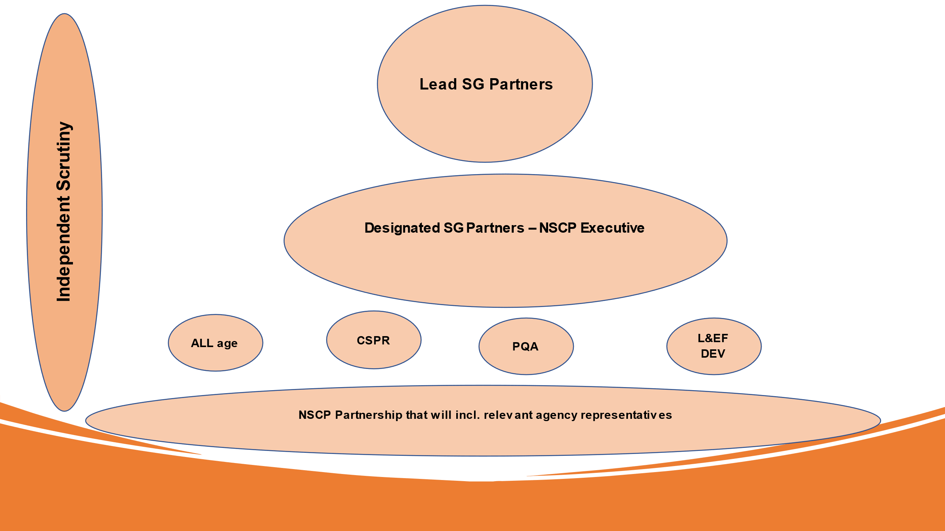

Signed by the statutory partners in the Newham Safeguarding Children Partnership

Borough Commander. Newham and Waltham Forest Police Basic Command Unit
Signed by – Charles Clare; Detective Superintendent



Chief Executive. Newham Council
Signed by – Laura Eden; Corporate Director of Children and Young People. LBN

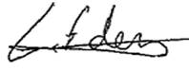

Chief Nursing Officer NHS North East London part of NHS North East London Health and Care Partnership.

Signed by - Korkor Ceaser; Deputy Director for Safeguarding Children

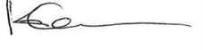

Date: 13 January 2025

