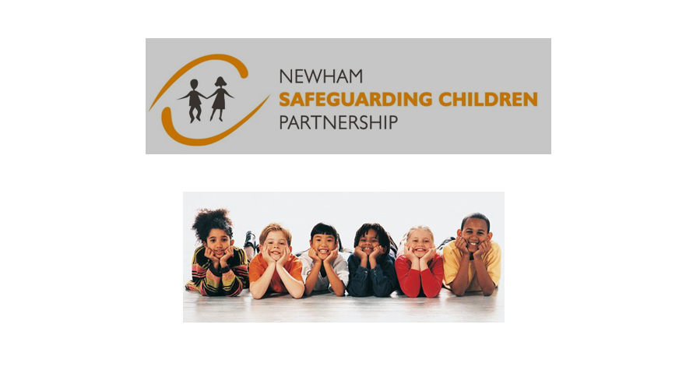

Newham Safeguarding Children Partnership Plan
2023-2026

Overview
Introduction
We are committed to ensuring that vulnerable children and families in Newham are provided with high quality support and protection and achieve the best possible outcomes. The business plan for 2023/26 reflects the priorities established at the priority setting event in January 2023 and the work with the partnership that has been undertaken six months prior in preparation. It is informed by data, Rapid Reviews, Child Safeguarding Practice Reviews and their associated learning, the knowledge and expertise of professionals and the views of children and young people. The Business Plan is reviewed annually and actions are monitored regularly by the NSCP Executive.
Vision
Making the best place for children and young people. All young people in Newham will:
• Grow up healthy, happy and safe
• Flourish in our schools
• Benefit from training and employment opportunities
• Play an active role in our community
Objectives
• To coordinate what is done by each agency to safeguard and promote the welfare of children
• To ensure the effectiveness of what is done by each agency and by agencies working together

NSCP Standards for an outstanding partnership
• The NSCP aims to be a mature, high trust partnership in which conflicts are resolved through conversation. This means
- A culture of early identification and referral to partners agencies
- Open and transparent dialogue between partner agencies
- Respect
- Handling disagreements through conversation which seek to arrive at a joint understanding
- No weak link in the ‘professional supply chain’ to a child
Priorities
GOLDEN THREAD:
A golden thread running through the priorities will be the consideration of the impact of poverty and the cost of living. For all priorities a special focus will be given to children with SEND, care leavers, unaccompanied asylum seekers and refugees.
NSCP and SAB joint priorities
- All age exploitation - with an emphasis on 16-25 age group with a focus on exploitation and youth violence
- Modern Day Slavery
- Cuckooing
- Domestic Abuse; To seek assurance that the domestic abuse strategy and accompanying action plans are reviewed annually and assurance is sought that safeguarding is at the forefront of the activity.

NSCP Children’s Partnership priorities
- Child sexual abuse including intra familiar sexual abuse and sibling sexual abuse.
- Child Mental Health.

The next actions are part of the NSCP business office service plan
- Communication and Engagement
We will ensure that the views of children and young people, and their parents and carers, contribute to developing best practice, and that frontline staff and managers are integral to informing learning and improvement.
- Activity – utilise the well-established groups of YP for their views
- Continue to produce 4 newsletters annually
- Review the NSCP website 6 monthly to ensure this is up to date

- Promoting Practice Improvement
We will work to, and promote, improvements to practice which builds on all aspects of good practice and what we know to be useful when assessing, implementing and evaluating what we do.
The learning and workforce development group brings together workforce development leads from across the partnership, sharing expertise, knowledge and resources. The group agrees the priorities for the NSCP annual training programme and updates to the NSCP website that will promote effective safeguarding practice and the content of partnership learning events.
The Child Safeguarding Practice Review group meets to identify serious child safeguarding cases (in which abuse or neglect of a child is known or suspected and the child has died or been seriously harmed). This group also ensures that cases requiring a child safeguarding practice review or a local safeguarding review as set out in Working Together to Safeguarding Children 2018 are identified and progressed. The group monitors and reviews action plans in order to ensure implementation of the learning and improvements identified.
Activity –sharing the learning from RR, SCPR and National Reviews Learning and development offer
- Multi Agency Data Set
- Multi Agency Audits
The Performance and Quality Assurance group aims to develop a data set which can be used to understand the pressures on the SG system and respond to emerging issues. The group develops and oversees a programme of multi-agency audits of practice. The group provides scrutiny and challenge to partner agencies in regards to their statutory safeguarding arrangements.

